Heat of Hydration of Portland and Composite Cements under Semi-Adiabatic Conditions
Abdur Nur Tushar¹, Zisan Zia², Rifat^{*3} and Raquib Ahsan⁴
¹ Undergraduate Student, e-mail: tushar11420@yahoo.com ² Undergraduate student, e-mail: zisanzia1@gamil.com
³ Research Assistant, e-mail: rifat.bin.ahmed@gmail.com ⁴ Associate Professor, e-mail: raquibahsan@ce.buet.ac.bd
Department of Civil Engineering,
Bangladesh University of Engineering and Technology (BUET), Dhaka-1000, Bangladesh
*Corresponding author: rifat.bin.ahmed@gmail.com

ABSTRACT
Early age temperature rise and thermal cracking potential of mass concrete are controlled by hydration heat. The hydration heat evolution of four commercially produced cements that meet the BDS standard EN 197-1:2003 CEM I 52.5 N, CEM II A-M 42.5 R, CEM II A-M 42.5 N and CEM II B-M 42.5 N under semi-adiabatic, sealed conditions at a w/c ratio of 0.40. The mineralogy of the clinker was identified by X-ray diffraction (XRD) and temperature–time histories were collected with a calibrated bench-top semi-adiabatic calorimeter, which were then processed in MATLAB by a lumped heat-balance model with a heat capacity function that depends on the degree of hydration of the mineral. The rate curves were solved by fitting a two-component Gaussian model and the cumulative curves were fitted by sixth order polynomial functions suitable for thermal simulation. The NIST Virtual Cement and Concrete Testing Laboratory (VCCTL) was used for independent simulations to validate. CEM I 52.5 N had the highest cumulative heat (≈467 J/g) and fastest kinetics while the CEM II B-M 42.5 N had the lowest cumulative heat (≈255 J/g). The release of ≈433 J/g was attained by the rapid-hardening CEM II A-M 42.5 R, which has more fineness than the normal-strength CEM II A-M 42.5 N (≈284 J/g), but not due to the level of clinker in the cement. VCCTL was able to reproduce the experimental ranking, with a difference of only ±3% for the high-clinker cements. This results in practical hydrating parameters and guidance for cement selection of mass concrete for tropical conditions.
Key-words: Cement hydration; Heat of hydration; Semi-adiabatic calorimetry; Composite cement; Thermal cracking; VCCTL; Gaussian model.

1. INTRODUCTION
During cement hydration, the clinker phases (tricalcium silicate (C₃S), dicalcium silicate (C₂S), tricalcium aluminate (C₃A) and tetracalcium aluminoferrite (C₄AF)) react with water, creating strength and heat. This heat is trapped in the core of mass concrete elements like raft foundations, bridge piers and thick mats, creating tension strains and temperature gradients that are higher than the early age tensile strength of concrete, and may lead to thermal cracking. A reliable prediction of the early-age temperature consequently requires accurate characterization of the hydration-heat of the cements that are in actual use in practice.
High clinker content makes ordinary Portland cement (CEM I) hydrate quickly and generate a high amount of heat, while the composite cement (CEM II) contain limestone, slag, fly ash or other supplementary constituents which dilute the clinker, slowing the rate of cement hydration and the heat emitted. One practically important exception is the “R” (rapid-hardening) class that has high early strength, largely due to fineness of grinding, not to high clinker content; thermal performance at early ages is often overlooked in the design of mass concrete.
Although lots of work has been done internationally, there is limited data for semi-adiabatic hydration-heat of commercially produced Bangladeshi cements that meet BDS EN 197-1, and few studies are available that combine mineralogical characterization, calorimetry, analytical modelling and numerical validation in one. This paper will fill this gap by examining four of those cements. The goals are to (i) characterize the mineralogy of clinker by XRD, (ii) measure the heat-generation rate and cumulative heat under semi-adiabatic conditions, (iii) develop two-component Gaussian and sixth-order polynomial model of heat evolution, (iv) validate the experimental ranking against NIST VCCTL simulations, and (v) translate results into guidance for cement selection in mass concrete projects in a tropical climate.

2. MATERIALS AND METHODS

2.1 Materials and Sample Identification
To cover the range of clinker content and mineral addition to be found in local construction, four commercially available cements were chosen (Table 1). To minimize pre-hydration and carbonation all samples were collected from sealed bags and stored in airtight containers. Cement pastes were cast at a water-to-cement ratio of 0.40 (139 g of cement and 57 g of water), mixed to a uniform consistency and sealed in the calorimeter vial and the time of cement–water contact, t = 0, was recorded.
Table 1. Cement types investigated and their expected thermal role.
Sample | Commercial type | Strength class | Expected hydration / thermal role
Cement 4 | CEM I 52.5 N | High, normal | High clinker → fastest hydration, highest heat
Cement 3 | CEM II A-M 42.5 R | Rapid hardening | Composite but finely ground → high early-age heat
Cement 2 | CEM II A-M 42.5 N | Normal | Moderate clinker dilution → intermediate heat
Cement 1 | CEM II B-M 42.5 N | Normal | Highest mineral addition → lowest, slowest heat

2.2 Mineralogical Characterization (XRD)
Clinker mineralogy was evaluated by using a PANalytical EMPYREAN diffractometer (45 kV / 40 mA, Cu Kα). The diffractometer was scanned between 6° and 90° 2θ at 0.026° step. Crystalline phases were identified by searching and matching to the ICDD PDF database and a semi-quantitative phase distribution was acquired using the reference-intensity-ratio (scale-factor) method, where the percentage of phase i is the ratio of the scale factor of i to the sum of all scale factors. The results are therefore only approximate relative proportions to explain the trends of hydration and to make VCCTL inputs.

2.3 Semi-Adiabatic Calorimetry and Calibration
A custom-made semi-adiabatic calorimeter, consisting of an insulated outer container surrounding a sample vial that is completely sealed and has both sample and ambient temperature sensors, recorded temperatures at 60-second intervals. The two calibration constants were measured. The effective heat capacity of the system was 3076.9 J/K, with an insulators heat capacity of 1386.6 J/K using electrical (heater) calibration. The heat-loss coefficient Kₗ was obtained through a free-cooling experiment, which was fitted to a lumped exponential model. In the semi-adiabatic case the heat flow of the reactions is recovered from the temperature history through the lumped heat balance:
$q_{reaction}(t) = C ·\frac{dT}{dt}+ Kₗ · [T(t) - T_{amb}(t)]$ (1)
The first term is the heat accumulated within the system and the second the heat released to the environment. The rate is then normalized against unit mass of cement and cumulative heat is calculated using Simpson's 1/3 numerical integration:
$q\left(t\right)=\frac{q_{reaction}(t)}{m.c} ; Q(t) = \int_{0}^{t}{q\left(t\right)dt}$ (2)

2.4 Data Processing and Analytical Models
MATLAB was used to import the temperature data and resample it onto a uniform 5-minute time grid and smooth it, differentiate it and heat-loss correct it. The specific heat of paste was found to decrease with the advancement of hydration and hence the degree-of-hydration-dependent heat capacity was used, r(t) = Q(t)/Qₘₐₓ obtained from the heat curve and the apparent capacity was scaled as Cₐ(r) = 1160.67 (1.5 − 0.5 r). The resulting corrected heat-generation-rate curve, with an early aluminate shoulder and a large, dominant silicate peak, was fitted to a two-component Gaussian model:
$q(t) = A_{1} exp[-((t-μ_{1})/σ_{1})²] + A_{2} exp[-((t-μ_{2})/σ_{2})²]$ (3)
A sixth-order polynomial was used to fit the cumulative-heat curve:
$Q(t) = c_{0} + c_{1}t + c_{2}t² + ··· + c_{6}t⁶$ (4)

2.5 Numerical Validation (VCCTL)
The Hydration was simulated separately with NIST VCCTL with the XRD derived phase proportions with a water-to-cement ratio of 0.40 and isothermal condition. These parameters were obtained and compared with the experiments at a common age of 19 h: Simulated Degree of Hydration and Cumulative Heat Release. Relative difference between experimental and simulated cumulative heat was used to assess agreement, and reproduction of the cement ranking was used to assess reproduction of the cement ranking.

3. RESULTS AND DISCUSSION

3.1 Clinker Mineralogy
The semi-quantitative phase compositions (Table 2, Fig. 1) are obviously a set of stages from a clinker-dilution sequence. CEM II B-M 42.5 N contains the least alite (≈ 42.4%) and the most filler/SCM fraction (≈ 30.3%) while CEM I 52.5 N has the highest alite (≈ 58.8%) and the least filler/SCM fraction (≈ 3.9%). The two CEM II A-M cements have intermediate and almost the same clinker content, as the manufacturer states that the only difference is in the fineness of the cement. This mineralogical ordering is meant to predict the calorimetric ordering described below since it is the C₃S and C₃A heats of reaction that are the most significant.
Table 2. Semi-quantitative XRD phase composition (%).
Phase | CEM I 52.5 N | CEM II A-M 42.5 R | CEM II A-M 42.5 N | CEM II B-M 42.5 N
C₃S (Alite) | 58.8 | 51.5 | 50.7 | 42.4
C₂S (Belite) | 17.6 | 14.6 | 14.9 | 12.1
C₃A (Aluminate) | 9.8 | 7.8 | 7.0 | 6.1
C₄AF (Ferrite) | 9.8 | 7.8 | 7.0 | 6.1
Gypsum | 3.9 | 3.9 | 3.5 | 3.0
Filler / SCM | — | 14.4 | 16.9 | 30.3
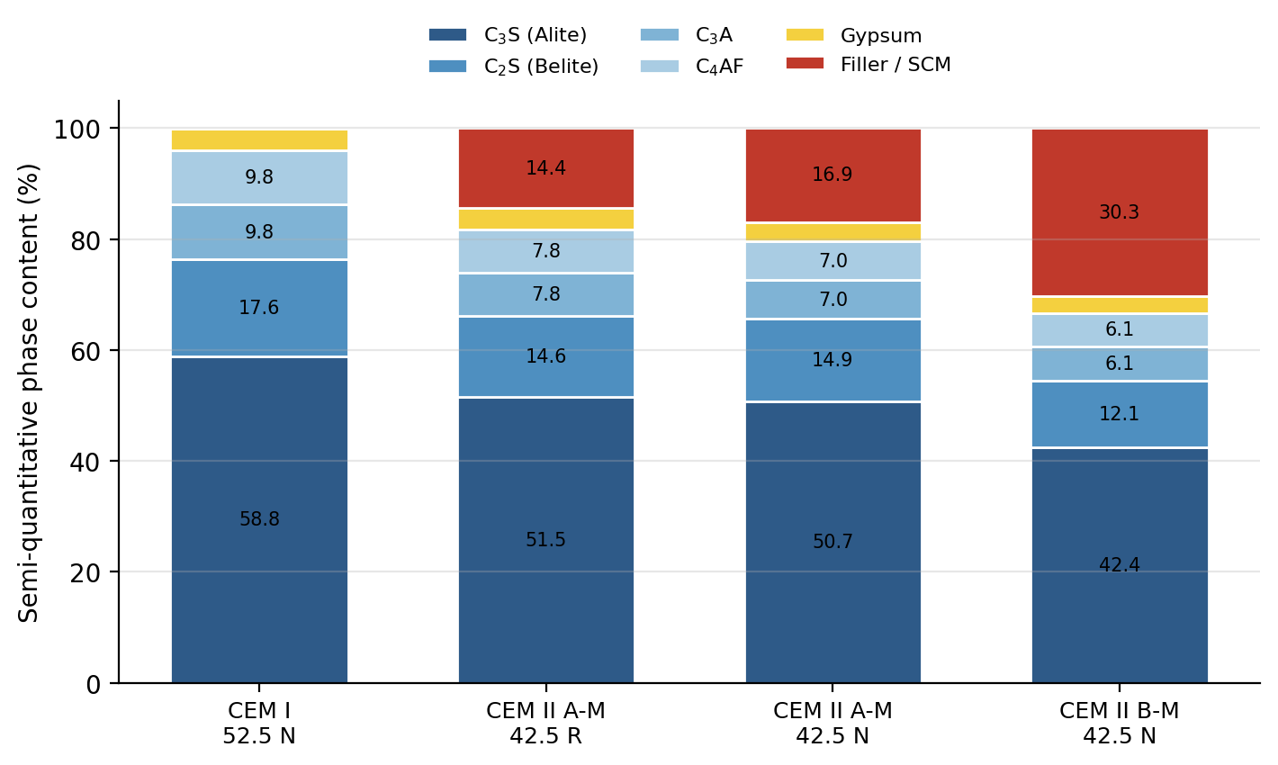
Fig. 1. Semi-quantitative XRD phase composition of the four cements, showing progressive clinker dilution from CEM I to CEM II B-M.

3.2 Heat-Generation Rate
The two experimental specific heat-generation-rate curves (Fig. 2) reveal the typical early occurrence of an aluminate shoulder and then the major silicate peak. The first main peak of CEM I 52.5 N appears at the lowest value and is the highest (≈ 3.0 J·min⁻¹·g⁻¹ at ≈ 290 min). The CEM II A-M 42.5 R has a wide, high silicate peak, while the normal strength CEM II A-M 42.5 N and CEM II B-M 42.5 N exhibit increasingly lower and more retarded peaks, due to the dilution of the clinker and slower reaction rates. The two-component Gaussian model was able to replicate the aluminate (G₁) and silicate (G₂) contributions and the parameters and terminal cumulative heat fitted is summarized in Table 3.
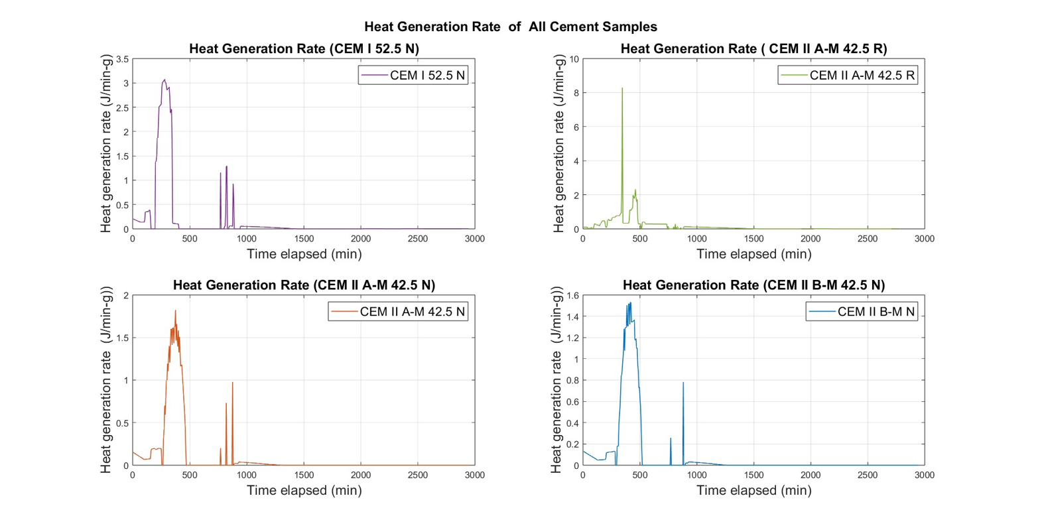
Fig. 2. Experimental heat-generation rate for the four cements (semi-adiabatic, w/c = 0.40).
Table 3. Two-component Gaussian parameters and terminal cumulative heat.
Parameter | CEM I 52.5 N | CEM II A-M 42.5 R | CEM II A-M 42.5 N | CEM II B-M 42.5 N
G₁ amplitude (J·min⁻¹·g⁻¹) | 0.40–0.45 | 0.30–0.40 | 0.15–0.20 | 0.12–0.16
G₂ amplitude (J·min⁻¹·g⁻¹) | 2.8–3.3 | 2.2–2.6 | 1.5–2.0 | 1.3–1.6
G₂ peak time (min) | 280–340 | 310–370 | 400–460 | 450–510
Terminal heat, exp. (J/g) | ≈467 | ≈433 | ≈284 | ≈255
Terminal heat, Gauss-2 (J/g) | ≈438 | ≈433 | ≈262 | ≈242

3.3 Cumulative Heat and Model Fits
The cumulative-heat curves (Fig. 3) confirm the ranking CEM I 52.5 N (≈ 467 J/g) > CEM II A-M 42.5 R (≈ 433 J/g) > CEM II A-M 42.5 N (≈ 284 J/g) > CEM II B-M 42.5 N (≈ 255 J/g). The most interesting finding is that the rapid-hardening CEM II A-M 42.5 R emits only about 7% less heat than CEM I, and approximately 52% more than the normal-strength CEM II A-M 42.5 N of nominally the same composition, which is directly attributable to the increased fineness of the Blaine fineness that accelerates the hydration of C₃S. Sixth order polynomial fits were applied to the cumulative curves and for all six cements, the R² value was > 0.999, allowing for continuous expressions to be used directly in finite element thermal models; the Gaussian rate model is more appropriate for mechanistic interpretation of the individual hydration stages.
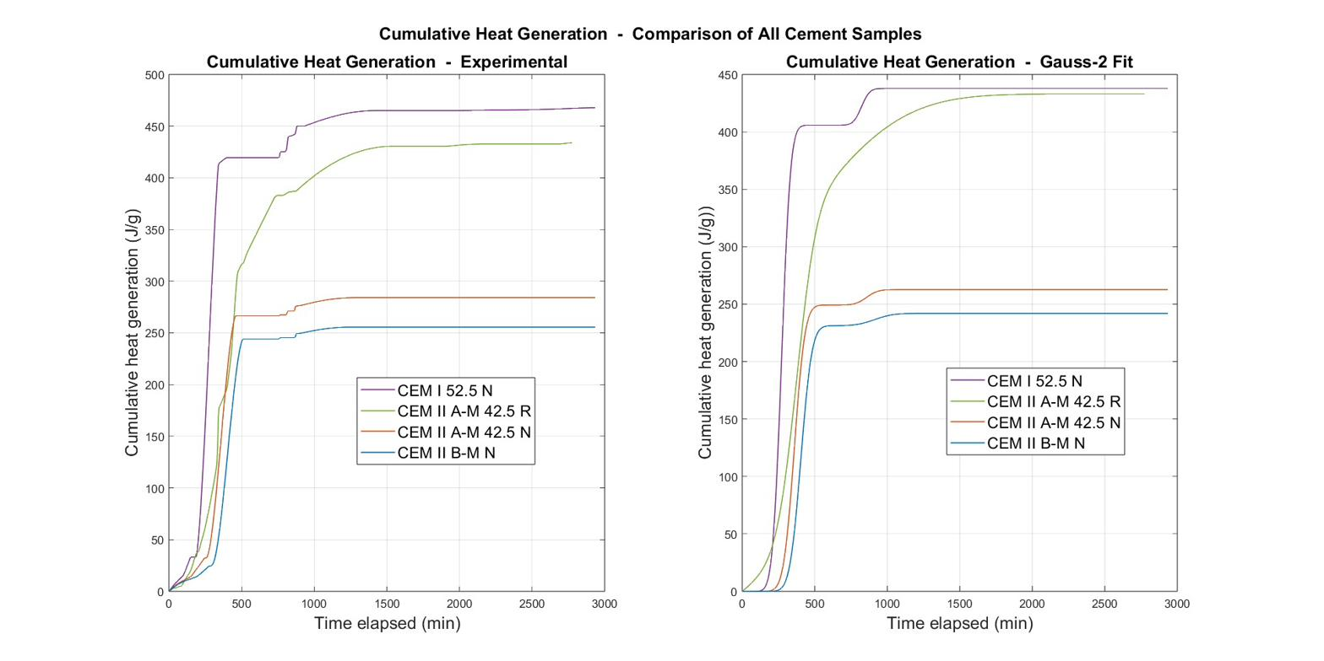
Fig. 3. Cumulative heat generation — experimental (left) and two-component Gaussian fit (right).

3.4 VCCTL Validation
The VCCTL simulations (Fig. 4) are consistent with the experimental thermal ranking and the mineralogical interpretation. At 19 h, CEM I 52.5 N reaches the highest simulated heat release (≈ 480 kJ/kg), CEM II A-M 42.5 R the second highest (≈ 445 kJ/kg), normal-strength CEM II A-M 42.5 N ≈ 390 kJ/kg and CEM II B-M 42.5 N the lowest (≈ 348 kJ/kg). It can be seen from table 4 that the simulation model is in good agreement with the experiment for the high clinker cements (CEM I and CEM II A-M 42.5 R) with about 3% difference while it over-estimates the slow blended cements by approximately 37%. This systematic over-prediction is to be expected: VCCTL is run under isothermal conditions and reaches the ultimate degree of hydration; the semi-adiabatic test is heat-loss-corrected and time-truncated, and the slow blended reactions were not completed by the time the monitoring was done. This isothermal idealization is reflected by the high simulated degree of hydration of CEM II A-M 42.5 N (≈ 0.95) which it does not contradict its low measured heat.
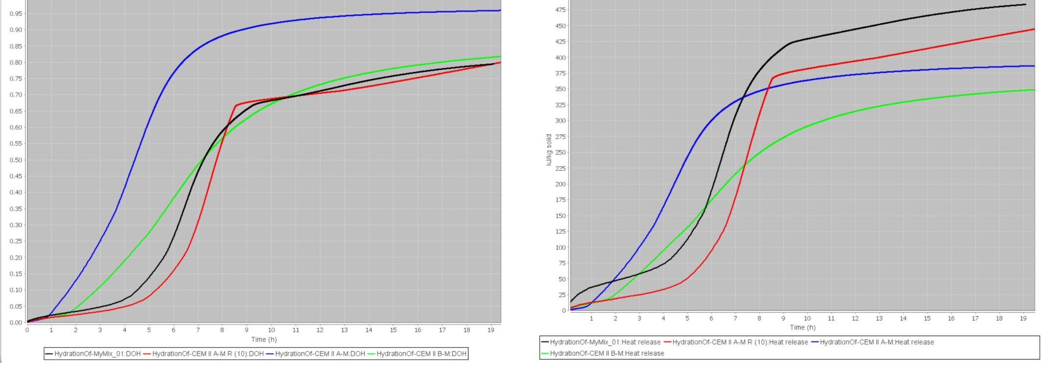
Fig. 4. VCCTL-simulated degree of hydration (left) and cumulative heat release (right) (isothermal, w/c = 0.40). Legend: MyMix_01 = CEM I 52.5 N; CEM II A-M = CEM II A-M 42.5 N; CEM II A-M R (10) = CEM II A-M 42.5 R; CEM II B-M = CEM II B-M 42.5 N.

Table 4. Experimental vs. VCCTL cumulative heat, simulated degree of hydration (DOH) at 19 h, and estimated thermal-cracking risk.
Cement | Exp. Q (J/g) | VCCTL Q (kJ/kg) | Rel. diff. (%) | DOH (19 h) | Est. ΔT (°C)
CEM I 52.5 N | ≈467 | ≈480 | +2.8 | 0.81 | >40
CEM II A-M 42.5 R | ≈433 | ≈445 | +2.7 | 0.80 | 32–38
CEM II A-M 42.5 N | ≈284 | ≈390 | +37.3 | 0.95 | 25–28
CEM II B-M 42.5 N | ≈255 | ≈348 | +36.5 | 0.825 | 22–25

3.5 Thermal-Cracking Risk and Practical Implications
Considering the 20 °C core-to-surface limit recommended by ACI 207R and CIRIA C660, CEM II B-M 42.5 N is clearly the most favorable for raft foundations, bridge piers and other temperature-sensitive placements, while CEM I requires active temperature control (pre-cooling, staged casting, insulation management) in thick sections. More importantly, CEM II A-M 42.5 R should not be considered as a low heat composite cement since it has close to Portland heat of hydration and requires the same thermal precautions as CEM I. The results of these findings are enhanced in the tropical context of Bangladesh, where the ambient temperature has further raised the internal gradient.

4. CONCLUSIONS
The following conclusions were reached in the study of four BDS EN 197-1 cements by using the combined XRD–calorimetry–modelling–VCCTL approach:
(1) Cumulative heat ranked CEM I 52.5 N (≈467 J/g) > CEM II A-M 42.5 R (≈433 J/g) > CEM II A-M 42.5 N (≈284 J/g) > CEM II B-M 42.5 N (≈255 J/g), in agreement with the XRD clinker-dilution sequence.
(2) The mineral content of the cement did not significantly affect its heat of hydration, as the rapid-hardening CEM II A-M 42.5 R performed virtually the same as Portland cement, with only a $≈$7% lower heat of hydration.
(3) VCCTL reproduced the experimental ranking and had a good agreement with the high-clinker cements within ≈3% and over-predicted the slow blended cements by ≈37% as expected from its isothermal, near-ultimate idealization.
(4) CEM II B-M 42.5 N is the preferred low-heat option for mass concrete in tropical conditions while CEM II A-M 42.5 R should be treated as a high-heat cement for mass concrete in tropical conditions.

5. ACKNOWLEDGEMENTS
The authors gratefully acknowledge their supervisor, Meghna Cement mills PLC. and the Department of Civil Engineering, BUET, for the laboratory facilities used in this study.

6. REFERENCES
[1] ACI Committee 207 (2005). Guide to Mass Concrete (ACI 207.1R). American Concrete Institute, Farmington Hills, MI.
[2] Bentz, D. P. (2007). Transient plane source measurements of the thermal properties of hydrating cement pastes. Materials and Structures, 40, 1073–1080.
[3] CIRIA (2007). Early-age thermal crack control in concrete (C660). CIRIA, London.
[4] De Schutter, G., & Taerwe, L. (1995). General hydration model for Portland cement and blast furnace slag cement. Cement and Concrete Research, 25(3), 593–604.
[5] Ferraro, C. C., Watts, B., Tao, C., & Masters, F. (2018). Advanced analysis, validation and optimization of virtual cement and concrete testing. University of Florida / FDOT.
[6] Klemczak, B., & Batog, M. (2016). Heat of hydration of low-clinker cements. Journal of Thermal Analysis and Calorimetry, 123(1), 1351–1360.
[7] Lothenbach, B., Scrivener, K., & Hooton, R. D. (2011). Supplementary cementitious materials. Cement and Concrete Research, 41(12), 1244–1256.
[8] Pane, I., & Hansen, W. (2005). Investigation of blended cement hydration by isothermal calorimetry and thermal analysis. Cement and Concrete Research, 35(6), 1155–1164.
[9] Rastogi, H., Moharana, S., & Subhash, S. (2024). Prediction of hydration properties and microstructure development of cement mortar using VCCTL. Discover Civil Engineering, 1, 152.
[10] RILEM TC 119-TCE (1997). Adiabatic and semi-adiabatic calorimetry to determine the temperature increase in concrete due to hydration heat of cement. Materials and Structures, 30(8), 451–464.
[11] Scrivener, K. L., Juilland, P., & Monteiro, P. J. M. (2015). Advances in understanding hydration of Portland cement. Cement and Concrete Research, 78, 38–56.
[12] Taylor, H. F. W. (1997). Cement Chemistry (2nd ed.). Thomas Telford, London.

